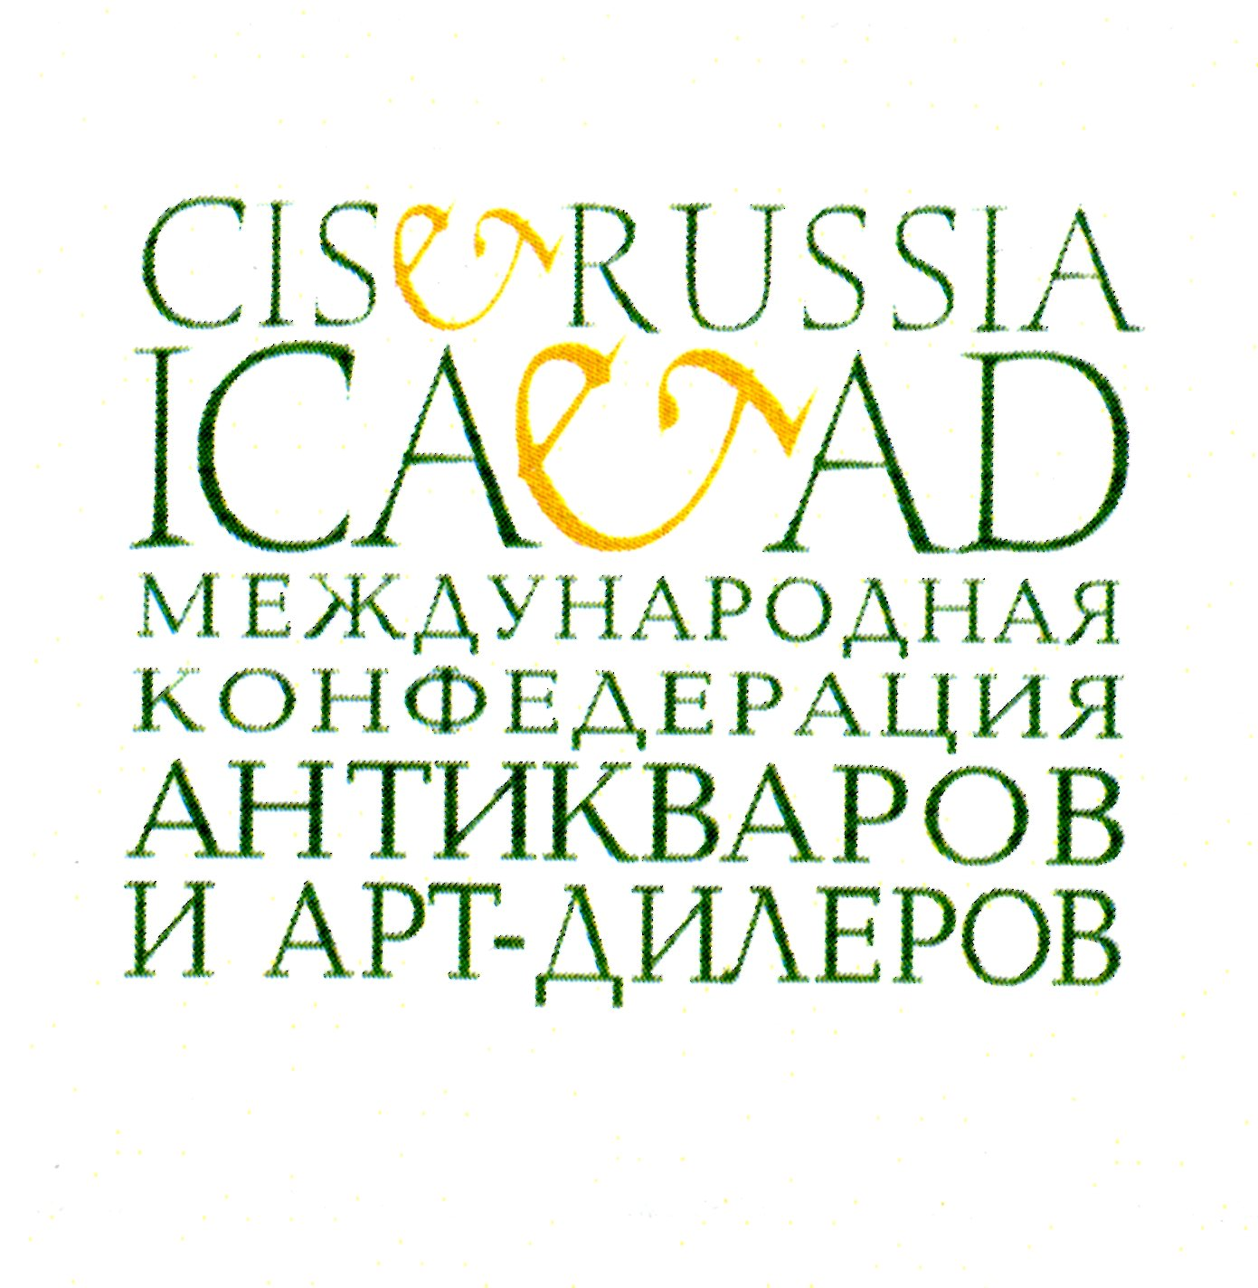
NATALIA GONCHAROVA
(1881-1960)

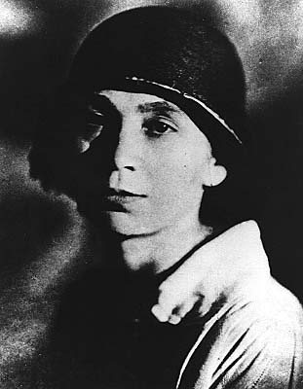

A SCANDAL

Natalia Goncharova. ‘Discoveries’

Introduction. 3

Background. 4

Stylistic comparisons. 4-7

Negative certificates of expertise. 8

Pre-1915 paintings by Natalia Goncharova. 9

Absence of credible provenance or exhibition history 10

The artist parodied. 11-12
The artist ridiculed 13-14
Signatures 14

Denouement. 15

Selling aids and price 15

Conclusions 15

Natalia Goncharova. ‘Discoveries’

Introduction.

In June 2013 German police broke up a major faking ring and seized 1,000 paintings purported to be by the major Russian avant garde artists, including Kandinsky, Malevich, Exter, Popova and the most expensive female artist at auction, Natalia Goncharova.

In this document, the International Confederation of Antique & Art Dealers of Russian and the CIS (ICAAD) together with leading Russian specialists, museum directors and collectors wish to bring the attention of the wider public this systematic faking of work by Goncharova and to protect her legacy.

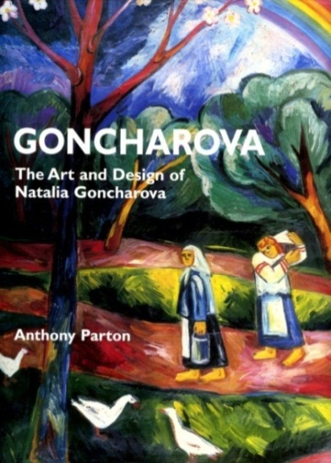

With a major retrospective of the artist having opened at the Tretyakov Gallery in Moscow on October 15th, we believe that the time is right to close the debate once and for all regarding hundreds of ‘new’ paintings by Goncharova, all given credence and purported authenticity with their reproduction in two monographs on the artist by misguided Western scholars and the author’s subsequent protection by a UK-based convention of long-since discredited historians of Russian Art.

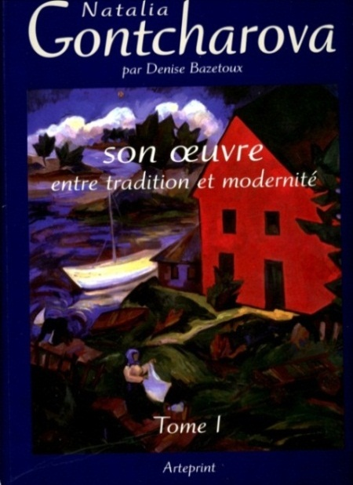

“Imagine. In Moscow a monograph is written on William Turner by a Russian art historian and within its pages are reproduced tens of new works, previously unknown both to a wider public and to specialists by the great Englishman. Imagine the battle between English museums to be first in the queue to buy these paintings. A sensation”.
Andrei Sarabianov, ‘The Alternative Goncharova’.
Artchronika magazine No. 2011

Background.

Natalia Goncharova is one of the greatest artists of Russia, an innovator, a revolutionary and, according to auction sales data, now the world’s most expensive female artist with prices up to $10,000,000.

In October 2010 and March 2011 two illustrated monographs about Goncharova were published in the West, ‘Goncharova. The Art and Design of Natalia Goncharova’ by Anthony Parton and the first volume of, ‘Natalia Goncharova. Her oeuvre, between tradition and modernity’, by Denise Bazetoux.

Whilst, normally, the attention of Western art historians to work by this Amazon of the Russian avant-garde and the popularization of her heritage would be welcomed, these books by Parton and Bazetoux saw reproduced, next to the well-known masterpieces and for the first time, hundreds of previously unknown paintings. These works which, at the very least, should be referred to as questionable from the point of view of authenticity (do not be fooled by the neutrality of this statement), have astounded Russian Art experts, collectors and connoisseurs of Goncharova’s work.

These ‘discoveries’ have been found in the main among those works connected with the period of Goncharova’s greatest innovativeness and of highest value at auction (is this a coincidence?) – those created during her life in Russia, pre-1915. It should be noted that the point under discussion is not one or two ‘discoveries’, which could potentially be explained by mistaken attribution on behalf of the authors, but about 150 strange new pictures, utterly lacking in credible provenance or exhibition history, which have caused bewilderment and horror.

In the first volume of the monograph by Denise Bazetoux are reproduced about 430 oils by Goncharova painted before 1915. 148 of these works are from museums and another 130 have a detailed provenance and exhibition history. Yet it is well known that Goncharova painted about 300 oils pre-1915 of which only 22 are unaccounted for. How, therefore, has Mme. Bazetoux come to the vastly inflated figure of 430?

The appearance of 150 new works by any major artist in such a short period of time (roughly the last 20 years) would be a major cause for doubt, even rigmarole, in many quarters but this is the situation and, with their publication in these two books, these mystery paintings are being passed off to museums, buyers and students as being genuine.
Stylistic comparisons.

An experienced art dealer or historian, when confronted with the comparison shown below, would have little difficulty spotting which painting was of dubious authenticity. When however, these paintings are analysed deeper, their absurdity and that of the other 150 paintings becomes clearer.

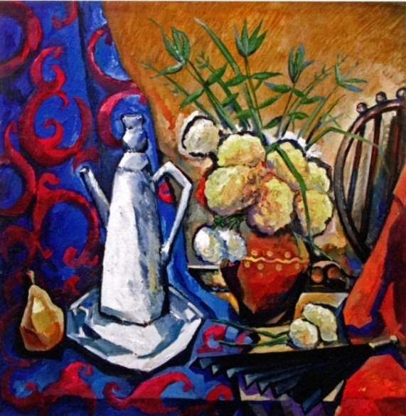

Figure 1
Natalia Goncharova (?)
‘Still life with a coffee pot and a fan’.
Anthony Parton : ill. 46, Denise Bazetoux; ill. 191
‘Private collection’
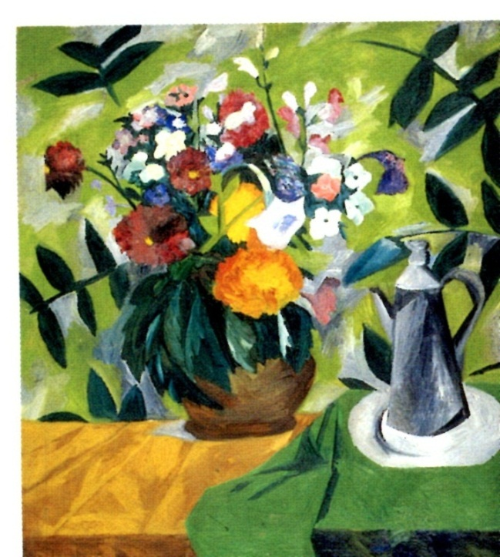
Figure 2
Natalia Goncharova
‘Flowers with a coffee pot’.
State Russian Museum, St. Petersburg
Aside from the total lack of creativity in the first illustration a comparison of the two coffee pots alone should be enough to convince of the dubious authenticity of Figure 1. It has a bent look with a lid more akin to that on a scent bottle, the handle has become rectangular and the entire composition shows a lack of confidence on behalf of the author, unsure whether the pot is multi-layered or smooth or how many corners the objects should have. By way of contrast, the coffee pot in figure 2 alone, to say nothing of the overall painting, clearly shows the subtle cubism and colour for which Goncharova was famous.
Further stylistic absurdities abound, for example the variations on themes, a concept which Goncharova virtually never applied to her pre-1915 oeuvre. Compare the subtlety of Figures 3 and 5 with the crude imitations of Figures 4 and 6.
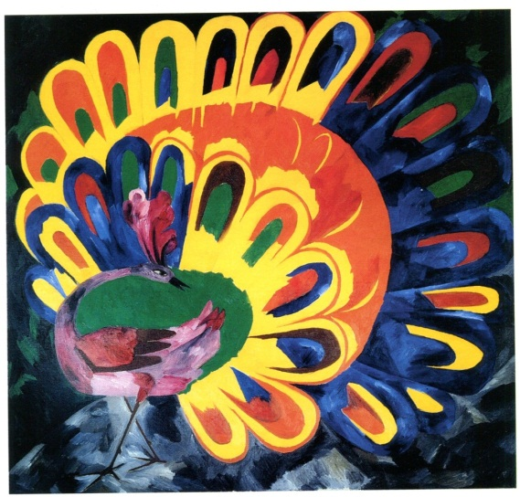
Figure 3
Natalia Goncharova
‘Peacock in sunlight’ (1911)
Tretyakov Gallery, Moscow

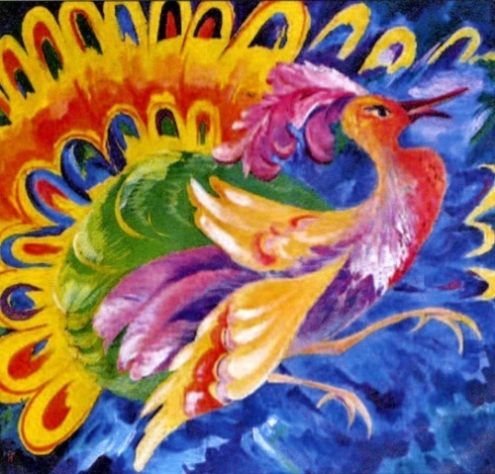

Figure 4
Natalia Goncharova (?)
‘Multi-coloured peacock’ (1910).
Denise Bazetoux; ill. 547
‘Private collection’
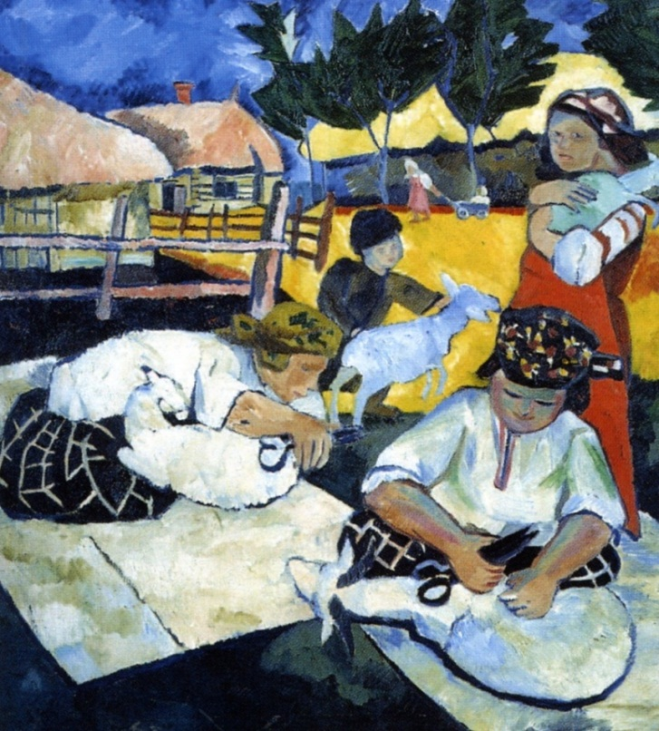
Figure 5
Natalia Goncharova
‘Sheep shearers’ (1907)
Museum of Serpukhov

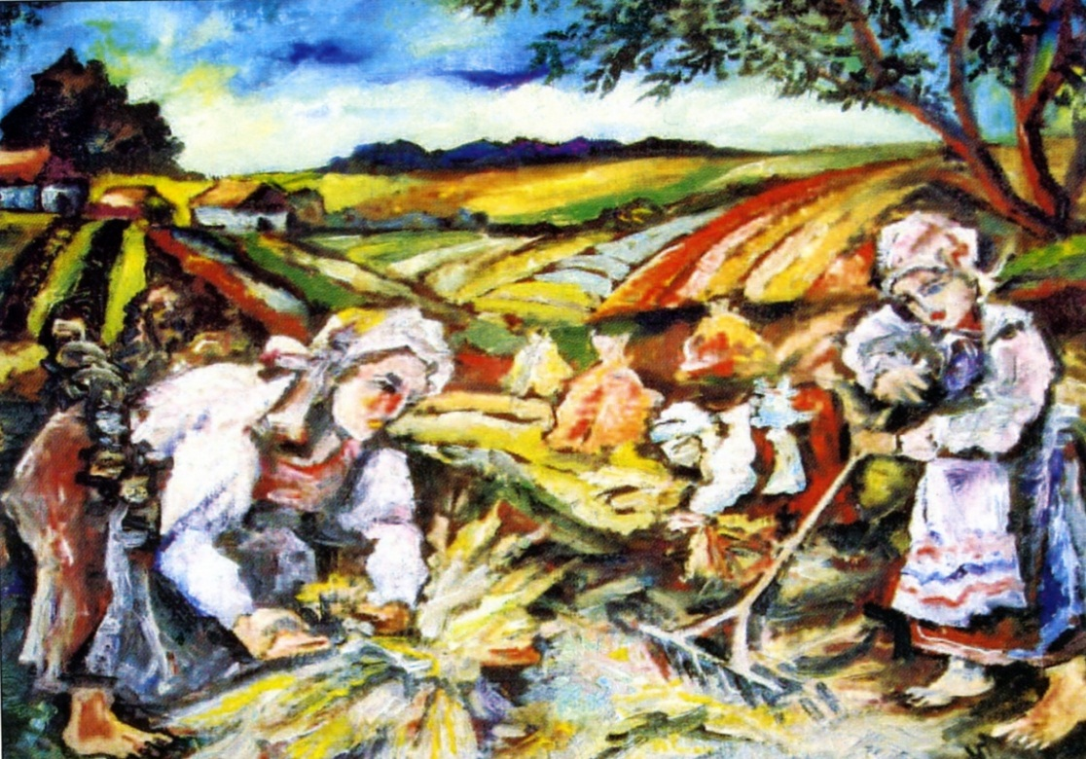

Figure 6
Natalia Goncharova (?)
‘Work in the fields’ (1906-7).
Denise Bazetoux; ill. 131
‘Private collection’
Negative certificates of expertise.

Whilst our doubts as to the authenticity of a whole section of works and the apparent absence of a responsible approach to the material chosen by these authors is based not only on artistic and art historical facts, there is also further damning evidence.

Specialists from the Tretyakov Gallery which, it must be noted, holds the largest collection of works by the artist and her archives, travelled to Europe to view both ‘Still life with a coffee pot and fan’ (illustrated in figure 1) and ‘Still life with sunflowers’ (figure 7) and gave both paintings negative certificates of authenticity. Yet these paintings are reproduced in Anthony Parton’s book as genuine.

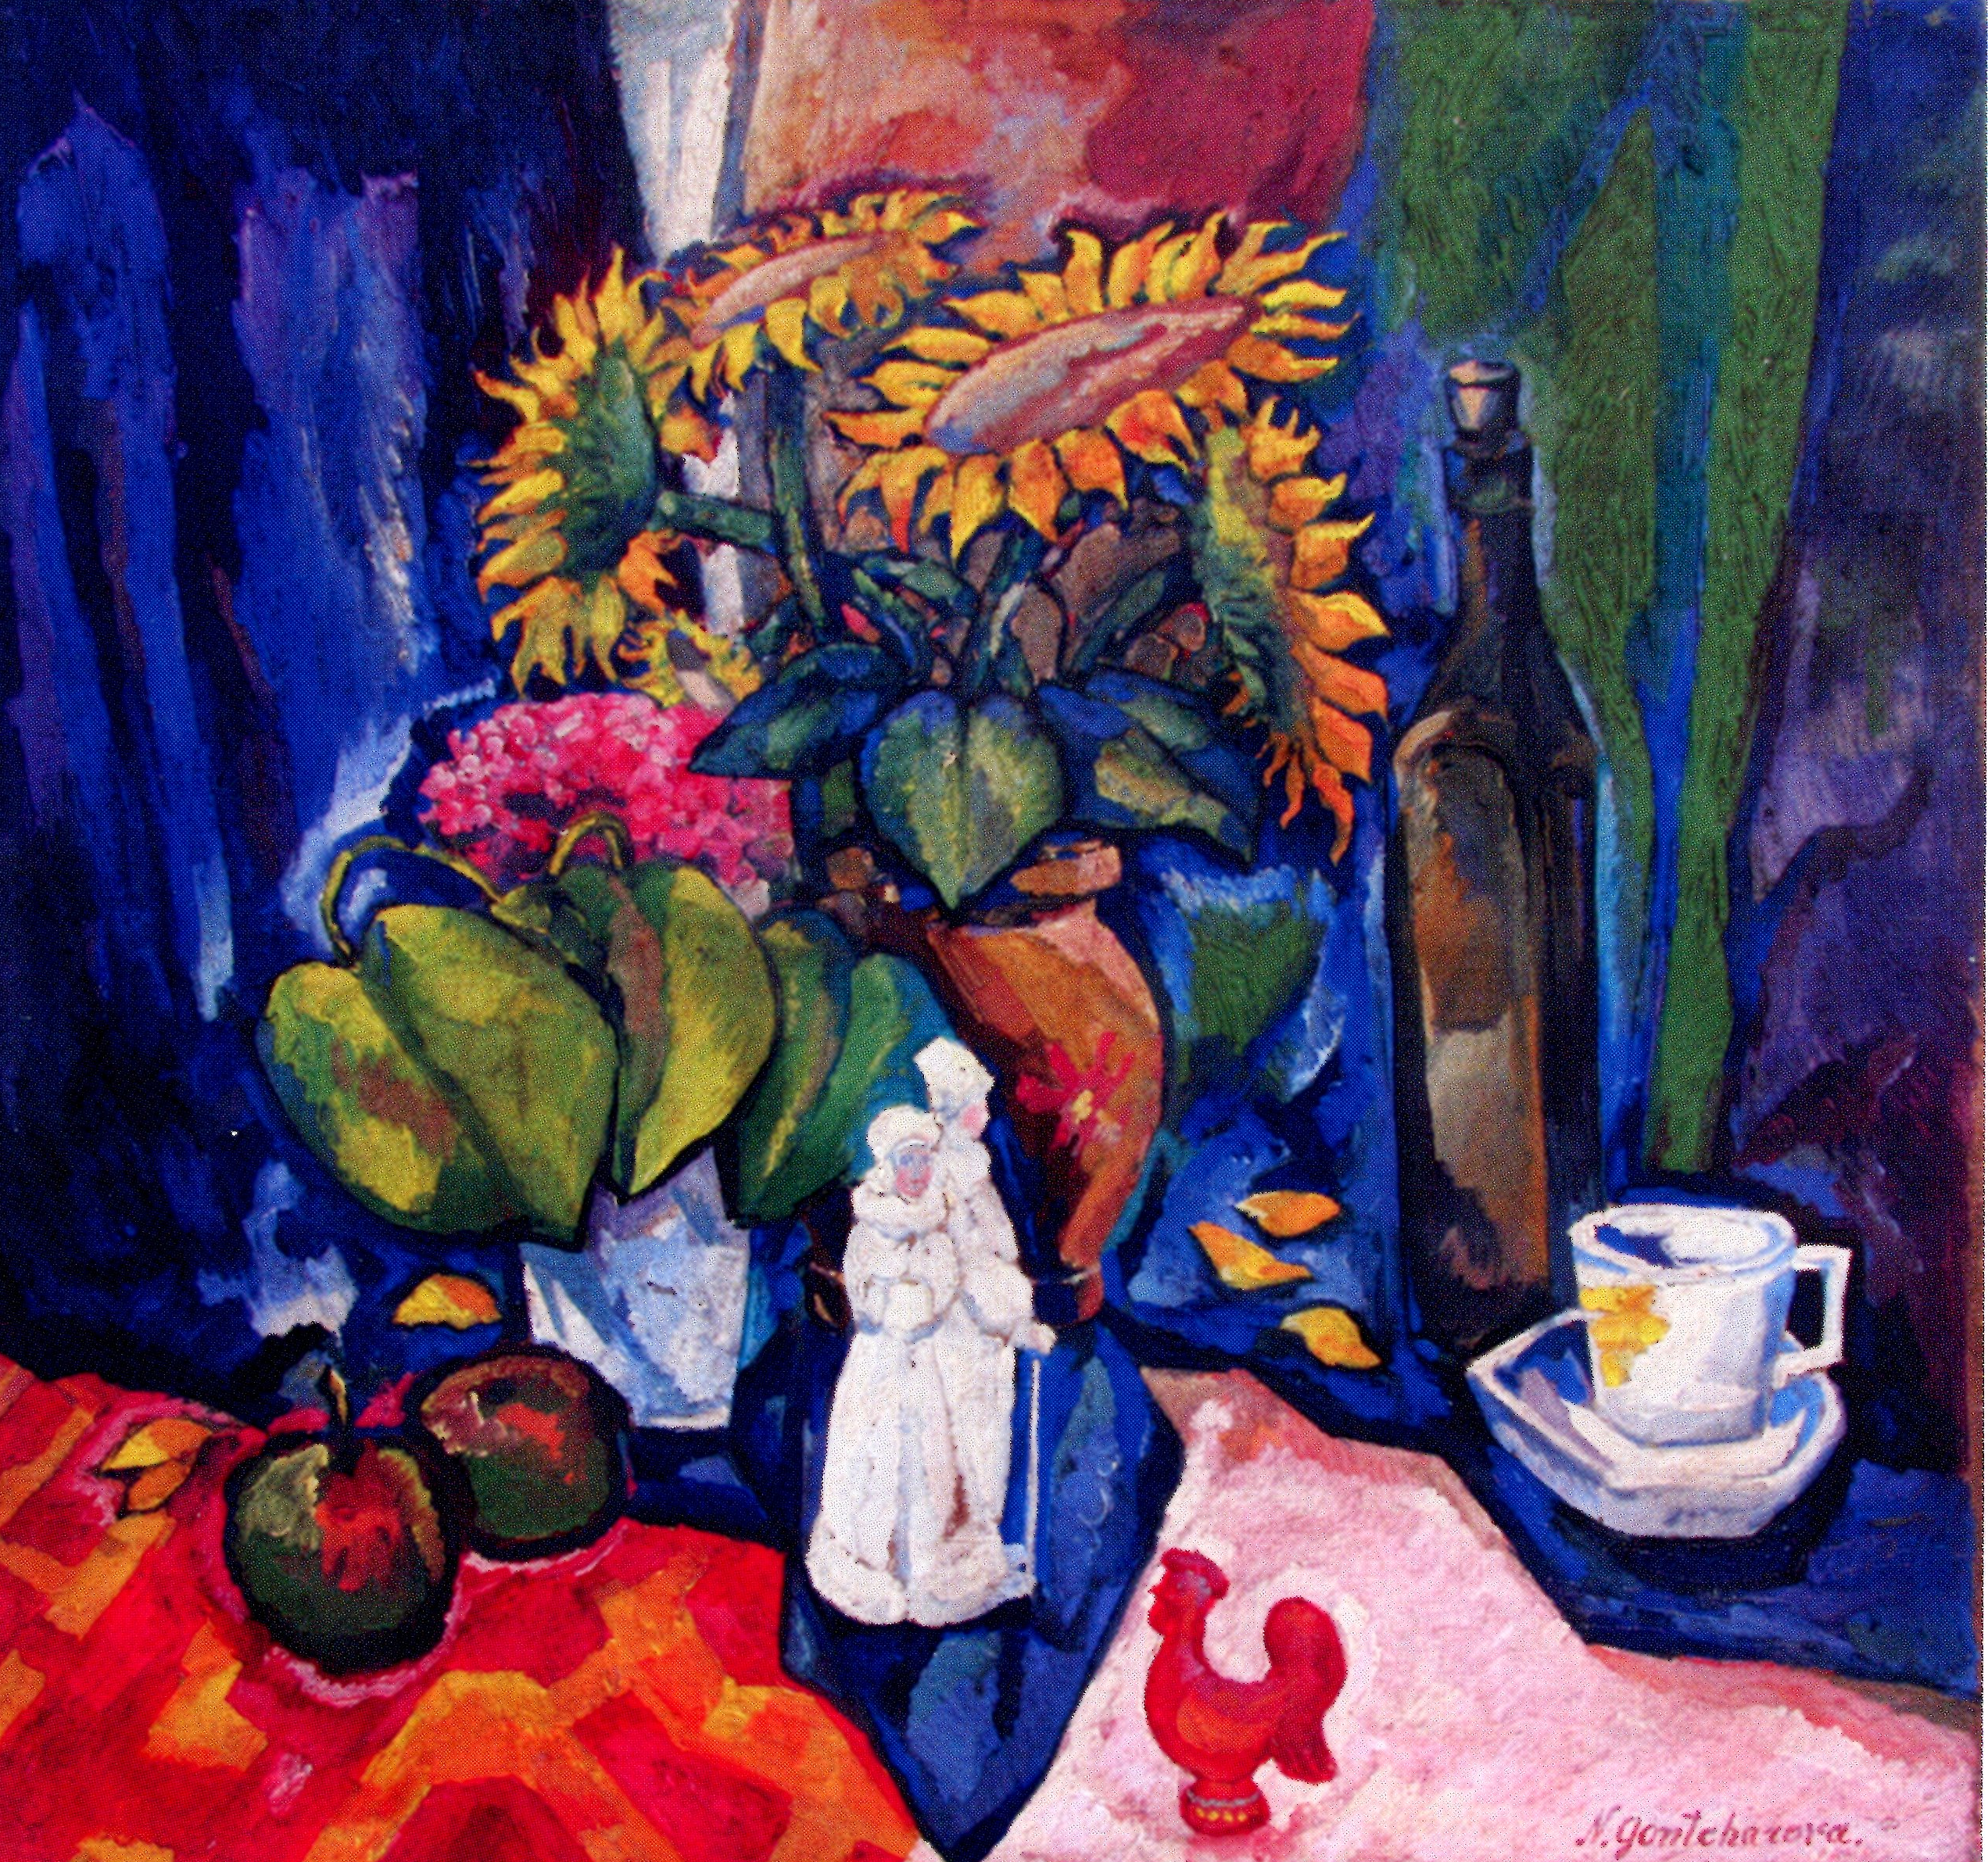

Figure 7
Natalia Goncharova (?)
‘Still life with sun flowers’ (1909).
Anthony Parton; ill. 47

It would be intriguing to know on what basis Anthony Parton authenticated these paintings and whether he is aware how his certificates, and those of Denise Bazetoux have been used as selling aids on the European art market? Indeed the question must be posed as to how many paintings by Goncharova Anthony Parton and Denise Bazetoux have actually physically seen, aside from photos?

We make such an accusation as neither author has investigated the Goncharova archives at the Tretyakov Gallery were lies the bulk of the material relating to her.
Pre-1915 paintings by Natalia Goncharova.

It is theoretically possible that original works by Goncharova created before 1915 with obscure provenance exist, but it is scarcely probable: this period has been well documented by contemporary art historians, whilst her work was actively exhibited and recorded in catalogues of the time.

There is an comprehensive, authorized list of works by Goncharova published in the brochure by Eli Eganbyuri in 1913 and a further list of works made by N.D. Vinogradov. The fate of the artist’s works which were left in Russia after her emigration to France with Larionov is also well known.

By way of an example as to our detailed knowledge of the movement of her paintings, in the Spring of 1914, Goncharova and her husband Larionov took about 50 of her paintings to Paris for their joint exhibition at the Paul Guillaume Gallery between 17th and 22nd June (there are actually 55 works of Goncharova). Of these paintings, 36 according to archive material at the Tretyakov Gallery from 1921, have special markings in German on the reverse and were returned to the artist in January 1921.

In 1915 Goncharova left Russia permanently and the greater part of her work was left in her Moscow flat. Between 1918 and 1919 some of the works were bought by the Department of Fine Arts of the People’s Commissariat for Enlightenment and were transferred to the Museum of Painting Culture. Later these works were handed over to the State Tretyakov Gallery and various provincial museums. Another significant part of their heritage was removed by N.D. Vinogradov, an architect, from the flat into the Moscow Depositary of Contemporary Art works founded by Vinogradov himself. On the reverse sides of these paintings special labels were stuck with the abbreviation of the depositary - ‘МХПСИ’, the first letters of the artists’ names ‘Г’ and ‘Л’ and numeration.

Between 1925-1926 the artist Lev Zhegin, acting on Larionov’s instructions, organized the shipment of these works to Paris. ‘Before transportation on the reverse of both Larionov’s and Goncharova’s paintings were inscriptions with the consignee’s name (purportedly in Zhegin’s hand): ‘Larionow’ and ‘Ларионов (this referred to the addressee as opposed to the author)’’ writes Irina Vakar, a senior specialist of the State Tretyakov Gallery on Russian Art of the first half of the 20th century.

Thus, most of the works created before 1915 have special marks on the reverse of the paintings. In the publications by Anthony Parton and Denise Bazetoux this vital information is often missed. These characteristic inscriptions, marks and stickers, well-known to specialists, could have thrown light on the movement and exhibition history of these questionable works.

Could one make an educated guess at the reason for the absence of such information?!

Total absence of credible provenance or exhibition history

We have already examined the stylistic and historical factors behind our accusations. The total absence of provenance with these dubious paintings is another part of our argument. Most dealers or experts working in any field of the arts will tell you that ‘miracles do not happen’ or, if they do, it is on a very rare basis. Yet here we have 150 ‘miracles’, a statistic unheard of in the history of the art market which the authors and the organisation that represents them, INCORM, seek to convince us is the truth? Let us examine just one painting to show the total absence of provenance, exhibition history and compare it with paintings which are held by museums and beyond any dispute.

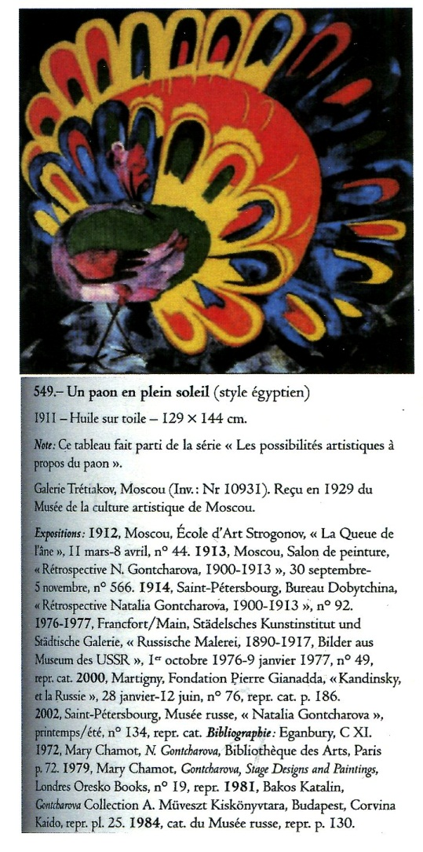 | 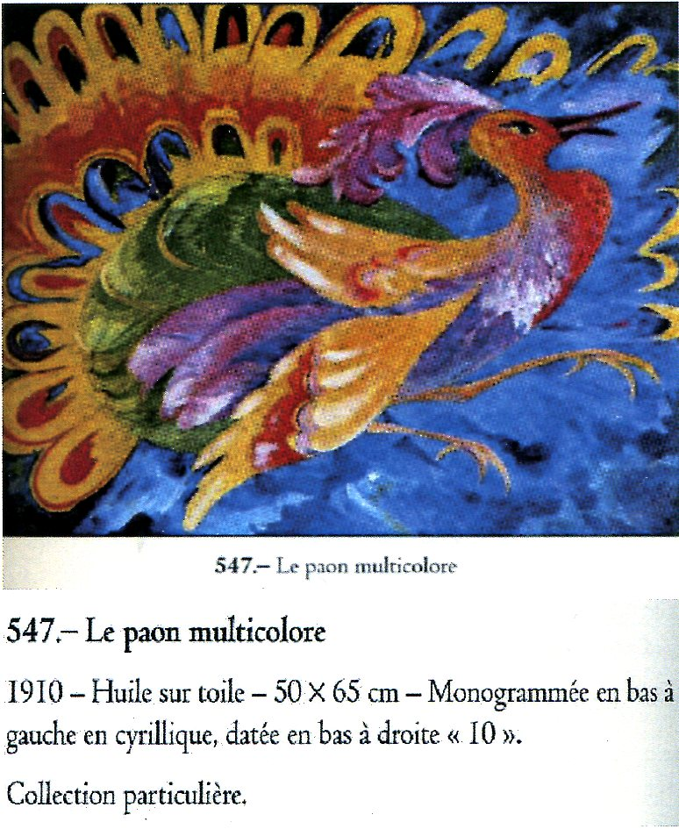

With the dubious painting on the right a Western art historian has used two words, ‘private collection’, which could refer to just about anyone and anywhere, as a provenance for a seemingly important futurist painting of the 1910’s. Taking into account the numerous exhibitions of Goncharova’s work, how is it that such an ‘important’ painting has never been before exhibited? Indeed how is it that none of the mystery 150 have ever been shown publicly? What possible set of circumstances are there? As the authors and INCORM have resolutely refused to answer, or avoided, our questions since 2011 we can only guess. That time is at an end.

The artist parodied.
“We consider that the publication of Professor Parton’s book to be unforgiveable: Insulting, as it does the memory of great artists who are not in a position to stand up for themselves and need us to defend them”. Irina Vakar’s words may sound strong but are relatively weak when stacked up against the evidence of appalling versions of ‘Wrestlers’ and ‘Cyclist’ reproduced in these two books.
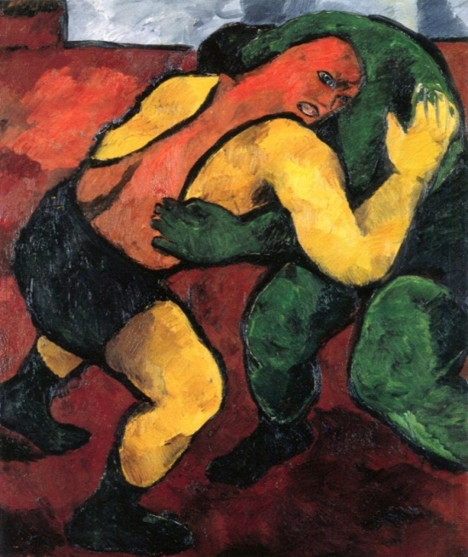
Figure 8
Natalia Goncharova
‘Wrestlers’ (1908-09)
Pompidou Centre, Paris
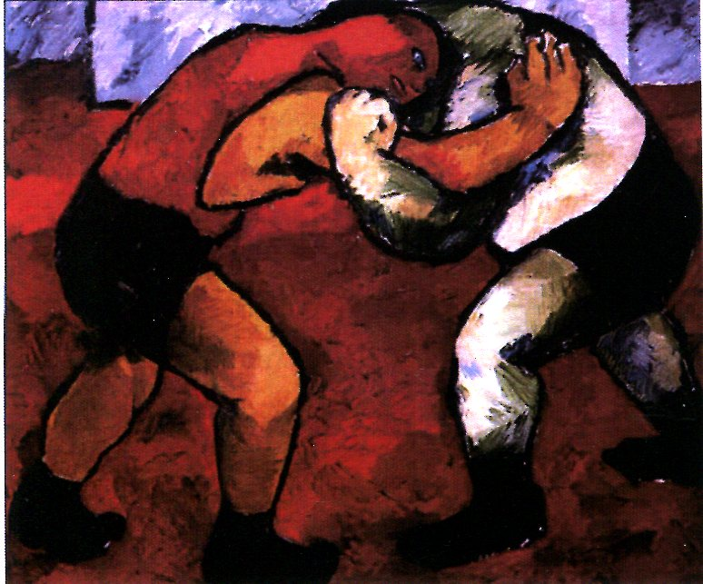
Figure 9
Natalia Goncharova
‘Wrestlers’ (1909-10)
State Russian Museum, St. Petersburg
It beggars belief, not just stylistically, to see a third version of ‘Wrestlers’, passed off as being by the brush of Goncharova by Anthony Parton. With no provenance and exhibition history, something of which we are becoming all-too familiar, this wooden, colour-free version becomes a veritable pastiche when set alongside the detail of a 1910 photograph that has clearly been used as its inspiration.
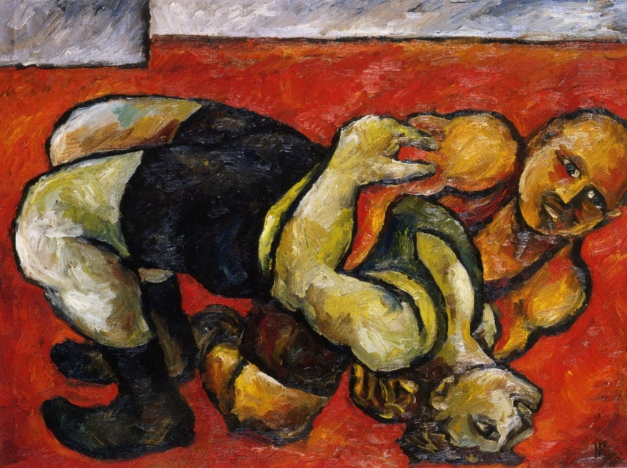
Figure 10
Natalia Goncharova (?)
‘Wrestlers’ (1900-10).
Anthony Parton; ill. 124
‘Private collection’
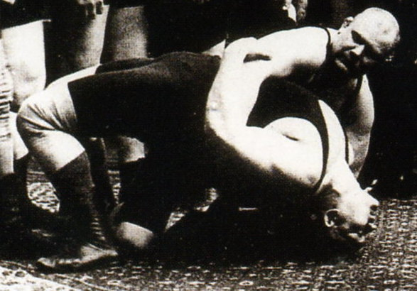
Photograph of the 1910 All-Russian championship of French wrestling.
“A photograph literally cut, pasted and transferred onto canvas.”
The artist ridiculed
“Her contemporaries were struck by the diversity of her work, the richness of fantasy. She hardly ever repeated a composition” Irina Vakar
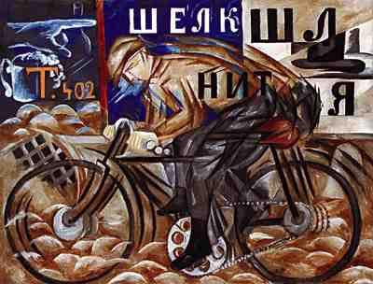
Figure 11
Natalia Goncharova
‘Cyclist’ (1911-12)
State Russian Museum, St. Petersburg

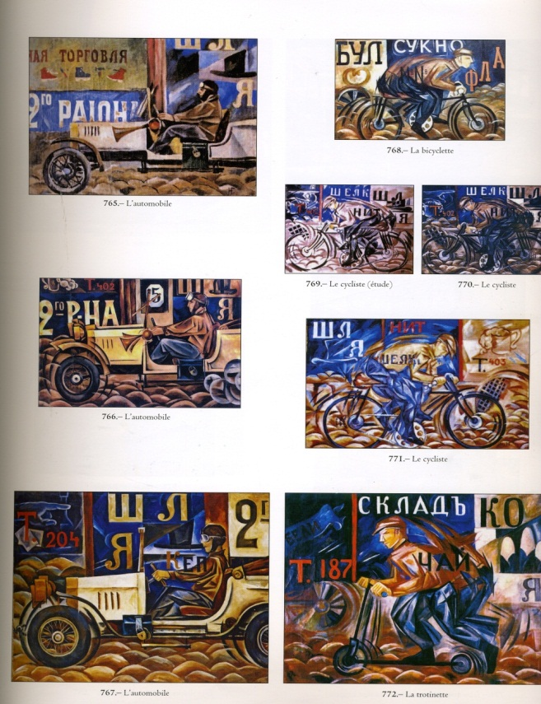 | 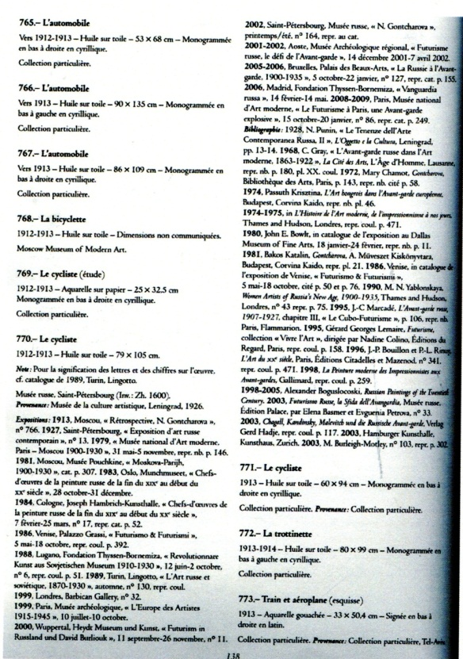

Figure 12
Denise Bazetoux, ‘Natalia Goncharova. Her oeuvre, between tradition and modernity’
page 309, illustrations 765-769, 771-772.
Figure 12 is surely the most damning piece of evidence in this pamphlet? It is a known fact that Goncharova hardly ever repeated a composition and yet here we have seven versions on a theme. So primitive is the attempt to connive the viewer that we have a series of bicycles going in a different direction from the original, various automobiles going from right to left on a variety of backgrounds and, absurdly, what is probably the first representation of the pushbike in Western Art history. Figure 12 also shows that every one of the seven to have the same non-provenance, ‘private collection’. Why was not one of these miracles exhibited in Goncharova’s lifetime? Is Western Art history really so backward as to believe that an artist as revolutionary as Goncharova created seven paintings on the same theme in the space of a couple of years?

Signatures

“A signature is a major rarity for works by Natalia Goncharova of her Russian period”

Had the authors investigated the pre-1915 work of Natalia Goncharova in any detail, they would have discovered that a signature on her work pre-1915 is a major, major rarity. It therefore almost goes without saying that of the 12 dubious paintings we have shown in this document, every single one is signed or monogrammed. When mass faking of Russian Art became public knowledge around 2000, it was a well-known that the majority of these dubious paintings were signed in an attempt to fool the buying public.

Selling aids and price

Should the authors doubt that these books and their certificates of expertise that proliferate on the Western Art market are used as selling aids, a glance at auctions in Germany over the last 10 years, or France will confirm the facts. For example, Lot 78 at a Paris auction house (illustrated below) in April 2011. The only credible evidence (the remainder of the provenance is entirely thought-up and cannot be proved) offered for the painting’s authenticity being a reproduction in Denise Bazetoux’s book and a certificate of authenticity from the author. It is instructive to note that the estimate for the painting is a fraction (20%) of what it would have been had the picture been genuine. Coupled to this is the fact that the major London auction houses, the centre of the Russian Art market, have long ago rejected certificates from these two authors as well as other members of INCORM. Why?

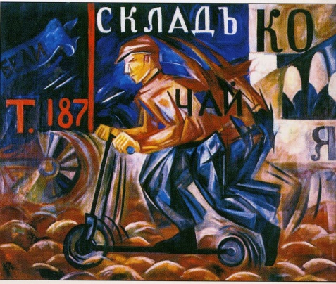 | Sale 9611 Lot 78  Natalia Sergeevna Goncharova (1881-1962)  La trottinette  Huile sur toile. Signée du monogramme en bas à gauche  80 x 99 cm 31 1/2 x 39 in  Estimation : € 800,000-1,000,000  Une attestation de Madame Denise Bazetoux sera remise à l'acquéreur  Provenance :  Acquis directement auprès de l'artiste. Collection Edward Ellenberg, Allemagne. Collection Egon Ellenberg, Paris  Collection particulière, Paris  Bibliographie:  Natalia Gontcharova, Catalogue raisonné de l'œuvre de Natalia Sergeevna Goncharova, Denise Bazetoux, éditions Arteprint,
Denouement.

In a May 2011 news conference, leading figures in the world of Russian Art including Irina Lebedeva, Director of the Tretyakov Gallery and Pyotr Aven, a major collector and specialist on Goncharova voiced their accusations. In reply, the authors were defended by the aforementioned ‘INCORM’ whose President, Patricia Railing, is herself an art historian.

The reply consisted largely of subterfuge and at no point answered the questions posed by the news conference nor those that have subsequently been aired on the artInvestment.ru site. Now, with the opening of the Goncharova exhibition at the Tretyakov Gallery we again seek dialogue to avoid the name of Goncharova being further besmirched.

To our request to have the dubious paintings chemically analysed to remove all doubt as to authenticity, we also offered to pay all costs, Mrs. Railing replied that these paintings “have “technological” expertises accompanying them by known and reputable scientists which reveal without a shadow of a doubt that the works were not “painted in our time” but were executed at least 60 years ago”.

These certificates to which Mrs Railing refers were, in the main, written by Erhardt and Elizabeth Jagers and yet we know that, according to the Press, German police have questioned the former who confesses in the Russian language version of the Art Newspaper from September 2013 that ‘if these (dubious paintings) were fakes, they were done extremely well’.

From the evidence of this document, we find this very difficult to believe.

Conclusions

In this document we have offered several factors for consideration:

- Stylistic
- Historical
- Provenance
- Copying and repetition
- Signature
- Price
- Chemical analysis

ICAAD feels that the time for answers has come. The Art world at large needs to know about these books, the harm they have done to the reputation of a great artist. We request that all copies are withdrawn from circulation, libraries and institutions. In addition we need to remind Anthony Parton, Denise Bazetoux and Patricia Railing of their responsibilities as art historians and to cease writing certificates on paintings that, on our evidence alone, cannot have been painted by the hand of Natalia Goncharova.

